Group 3

**User Manual**

**InPress**

Abdul Hadi Muhammad (0951862)

Liu Wenbo (0970709)

Justin Kan (0843763)

# 

# 1.0 Legal and Copyright Information

Copyright © 2014 by InPress All rights reserved.

No part of this publication may be reproduced, stored or transmitted in any form or by any means, electronic, mechanical, photocopying, recording or otherwise without prior written permission by InPress®

Reproduction prohibitions do not apply to the forms contained in this product when reproduced for personal use.

Table of Contents

1.0 Legal and Copyright Information 2

2.0 Introduction 4

3.0 Getting Started 4

3.1 System Administrators 4

3.1.1 Configuring the Server 4

3.1.2 Configuring InPress 5

3.1.3 Creating Instructors 5

3.2 Instructors 6

3.2.1 Login 6

3.2.2 My Courses 6

3.2.3 Add a Course 6

3.2.4 Remove a Course 7

3.2.5 Student Enrollment for a Course 7

3.2.6 Add an Assessment 8

3.2.7 Remove an assessment 8

3.2.8 Post, Unpost assessments 9

3.2.9 Modifying Effective Date for assessments 9

3.3.0 Viewing assessments 9

3.3.1 Add Questions 9

3.3.2 Remove Questions 10

**4.0 Students …………………………………………………………………………………………………………….11**

4.0.1 Logging In**…………………………………………………………………………………………………..11**

4.0.2 Courses Selection and Assessments**………………………………………………………………11**

4.0.3 Assessments**……………………………………………………………………………………………….13**

4.0.3 Reviewing Assessments**……………………………………………………………………………….14**

# 2.0 Introduction

InPress is a web-based application, which allows students in universities and colleges to respond in real time to questions posted by their instructor. It is supported on any internet-enabled device including tablets and mobile devices. The goal is to improve student engagement in the classroom through the use of the latest technologies. InPress has three key users – System Administrators, Instructors and Students. This document will cover the essentials of InPress®, and will walk through the software. Technical aspects of the software will not be discussed in this document. Technical details are discussed in the InPress Design Document

Wi-Fi, 3G, 4G, LTE



***Figure 1:***

***Outline of how InPress is used in the classroom***

# 3.0 Getting Started

This user manual is divided into three sections, where each section represents a different type of user. These three levels of users are System Administrators, Instructors, and Students. The System Administrators will have access to the hosting server, the Instructors and Students are on the client side.

## 3.1 System Administrators

### 3.1.1 Configuring the Server

1. InPress requires a physical or virtual machine to act as a server. The minimum requirements are below:
   1. Operating System: Microsoft Windows, Apple Mac OS, Linux
   2. RAM: 2 GB of RAM
   3. Hard Drive: 250 MB of hard drive space
   4. Processor: 1 Core 2.6 GHZ
2. Install the following packages on the server:
   1. Python (<http://www.python.org/downloads/>)
   2. Django (<http://www.python.org/downloads/>)
   3. PostgresSQL (<http://www.postgresql.org/download/>)
   4. PgAdmin (<http://www.pgadmin.org/download/>)
   5. Apache Server ( <http://httpd.apache.org/> )
3. Configure PostgreSQL:
   1. Open PgAdmin
   2. Create a server with the following credentials:
      1. name: inpress
      2. user: postgres
      3. password:
      4. host: localhost
      5. port: 5555
   3. Once a server has been successfully created, create a database named  
      ‘inpressdb’ within the server you created in step b.

### 3.1.2 Configuring InPress

1. Navigate to the following URL: <https://github.com/hadimuhammad/InPress>, and click on **Download Zip** (Located on the right)
2. Unzip the zip file you obtained in Step 4 in a location where you wish to deploy your InPress (e.g ~/inPress)
3. Navigate to the following location in your InPress directory – InPress/ and execute the following commands:
   1. python manage.py syncdb

*[If the above command yields errors, ensure that you database is setup and ensure that the settings in InPress/inPress/settings.py are correct and match up the settings in Step 3]*

* 1. If this is your first executing this command, then you will be asked to provide a user name, password, email address for the admin console. Ensure you keep these credentials in a safe place. **If you lose it you will have to re-create the database!**

1. In order to run InPress, execute the following: python manage.py runserver <server_address>:<port> where port is the port number you would like to use (i.e. inpress.com:8132, inpress.com is the server address and 8132 is the port).

**3.1.5 InPress to Production**

1. Install mod_wsgi (<https://code.google.com/p/modwsgi/>)
2. Go to your home directory and create inpress.wsgi
3. Input the following into inpress.wsgi

**import os**

**import sys**

**sys.path = ['/var/www/inPress'] + sys.path**

**os.environ['DJANGO_SETTINGS_MODULE'] = 'inPress.settings'**

**import django.core.handlers.wsgi**

**application = django.core.handlers.wsgi.WSGIHandler()**

1. Copy all of InPress files to “/var/www”
2. Go to the directory “/etc/apache2/sites-avaliable”
3. Create the file “inpress.conf” , and make sure you are in **SUDO or ROOT**
4. Input the following into “inpress.conf”

**<VirtualHost *:80>**

**WSGISCriptAlias / <your inpress.wsgi full-path>**

**Servername <hostname / IP>**

**Alias /static /var/www/inPress/module/static**

**<Directory /var/www/inPress/>**

**Order allow,deny**

**Allow from all**

**</Directory>**

**</VirtualHost>**

1. Change directory to “/var/www/inPress/inPress”
2. Open the file “settings.py”
3. Turn DEBUG to FALSE (DEBUG = False)
4. Save and Reload apache service (service apache2 reload)

### 3.1.4 Creating Instructors

1. In order to create an instructor:
   1. Navigate to the **<server_address>:<port>/admin** url
   2. Enter the credentials you created in Step 7
   3. Click on the Instructors Table
   4. Click **Add New**
   5. Add the instructors credentials
   6. Click **Save**

## 3.2 Instructors

### 3.2.1 Login

1. Instructors can login through the URL the system administrator provides them (i.e. **<server_address>:<port>**). The following window should appear:

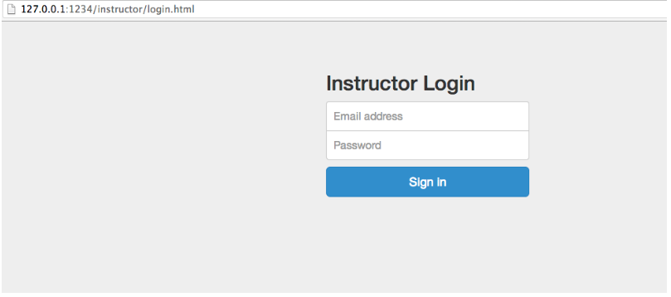

*Figure 2 - Instructor Login Page*

1. Enter the credentials provided by the System Administrator

### 3.2.2 My Courses

1. From the **My Courses** webpage, instructors can easily access a course, and add/remove a course. The top menu contains the homepage shortcut, the dropdown list of My Courses and Logout Button. (***Figure 3)***

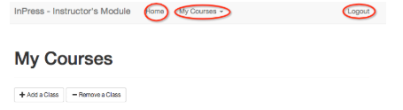

*Figure 3 - My Courses Webpage*

### 

### 3.2.3 Add a Course

1. From the **My Courses** webpage, instructors can easily access a course, and add or remove a course. Click on **Add a Class** from the My Courses webpage to add a course.
2. For a course to be created its name, course code, and class list must be inputted. The class list is a text file with all the student numbers of all students enrolled in that class. Once complete, you should see a screen like this:

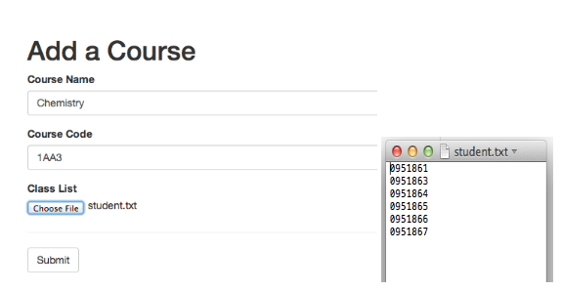

*Figure 4 - Add a Course webpage*

1. Once complete, click **Submit.**

### 3.2.4 Remove a Course

1. From the **My Courses** webpage, click **Remove a course**.
2. Select the course you want to remove

### 3.2.5 Student Enrollment for a Course

1. After a course is created, instructors have the option to add or remove students to the course by selecting **Student Enrollment** from the course webpage.
2. Instructors can add more students by entering a student’s number and clicking **Add Student.**
3. Instructors can remove students by choosing the student numbers from the list below and clicking **Remove Students**.
4. Remember to click **Save** to save all changes. Failure to **Save** will result in no changes to the class roster for that course

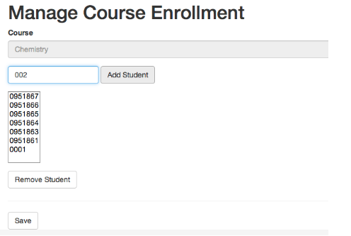

*Figure 5 - Manage Course Enrollment*

### 3.2.6 Add an Assessment

1. To create a new assessment, click on **Add Assessment** located at the bottom left of the course page (***figure 3***).
2. Enter the assessment name along with its effective date. The *effective date* is the date of which the assessment is going to be available to the students. Click **Submit** to create the assessment.

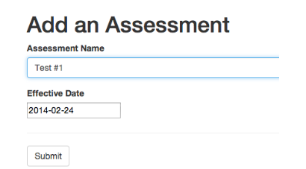

*Figure 6- Adding an Assessment*

### 

### 3.2.7 Remove an assessment

1. From the coursewebpage, click **Remove an Assessment**
2. Select the assessment you want to remove

### 3.2.8 Post, Unpost assessments

1. Navigate to the assessment that you would like to post
2. Click on **Post** or **Unpost.** Students are unable to see unposted assessments. Posted assessments with a current/prior effective date are viewable by students (***figure 7***).

### 3.2.9 Modifying Effective Date for assessments

1. Navigate to the assessment that you would like to modify
2. Click on the small pen icon to change the effective date, and select the date of your choice
3. Select the same pen icon again to register the new date to the system.

### 3.3.0 Viewing assessments

1. New assessments will appear on the course page as a drop down table
2. If an assessment is **Online (posted)**, students are able to view the assessment
3. If an assessment is **Offline (not posted),** students are not able to view the assessment
4. If an assessment is **Offline until <date> (not posted),** students are not able to view the assessment until that date.
5. 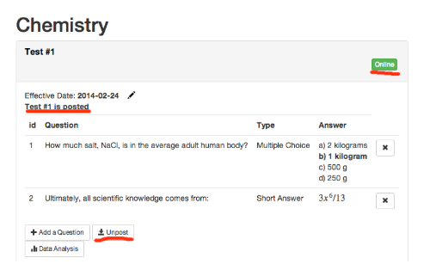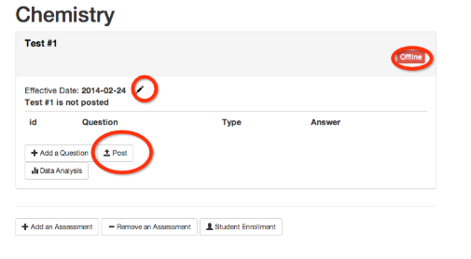If an assessment is **Post Date Passed,** students are able to see the assessment in their history.

*Figure 7 - Viewing assessments*

### 

### 3.3.1 Add Questions

1. Instructors can create questions for an assessment by clicking **Add a Question.** A question can be a **Multiple Choice** or **Short Answer** type.
2. For Multiple Choice, Instructors need not to fill out all blanks. Once the question and choices are added, ensure that the radio button is selected for the correct answer.
3. Instructors may use LaTeX by encapsulating the code in \( \).

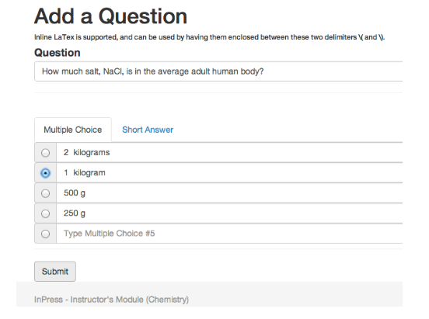

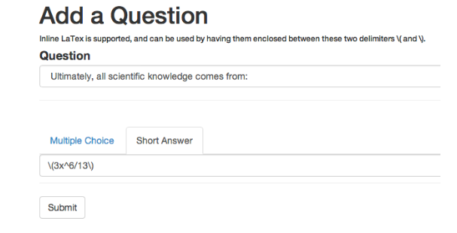

*Figure 8 - Add a Question*

### 3.3.2 Remove Questions

1. Locate the question you want to remove
2. Click on the X beside it

# 4.0 Students

The following are for Students. Instructors should also learn how to use this so that you can guide your students through this application.

**4.0.1 Logging In**

1. Navigate to the server address provided by the Instructor.
2. You will see a Student Login Screen (***fig 4.0.1a)***
3. Enter Student Number
4. Click on “Sign In”

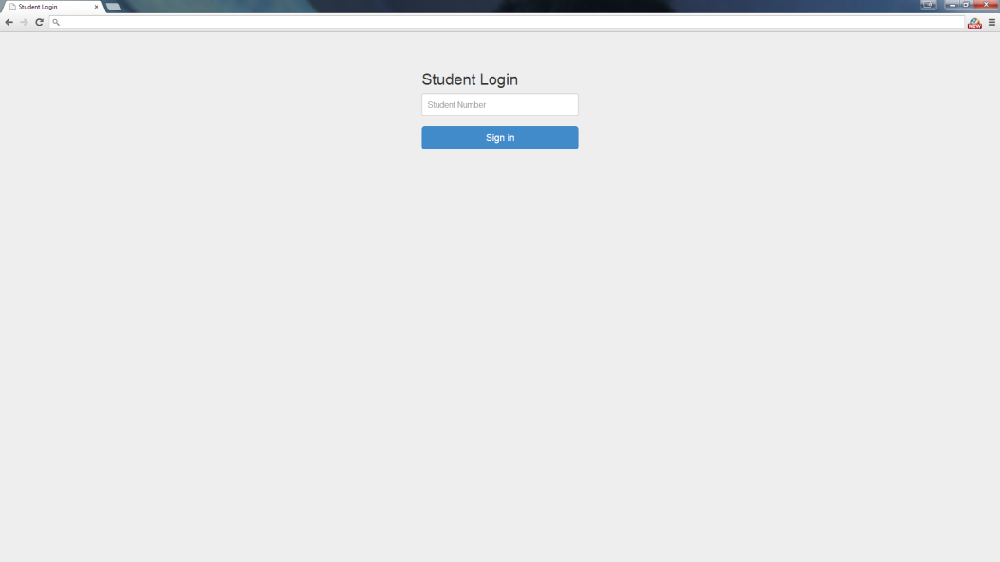

***Fig 4.0.1a – Student Login Screen***

**4.0.2 Courses Selection and Assessments**

1. When you are logged in, click on the course that you want to choose *(****fig 4.0.2a)***
2. When you chose the course, you will see the Assessments Page. Here you will be able to find a variety of Assessments such as Tests, Homework, Quizzes etc ***(fig 4.0.2b)***
3. You may click on “Home” or “My Courses” at the top of the page (indicated in red, ***fig 4.0.2a***)

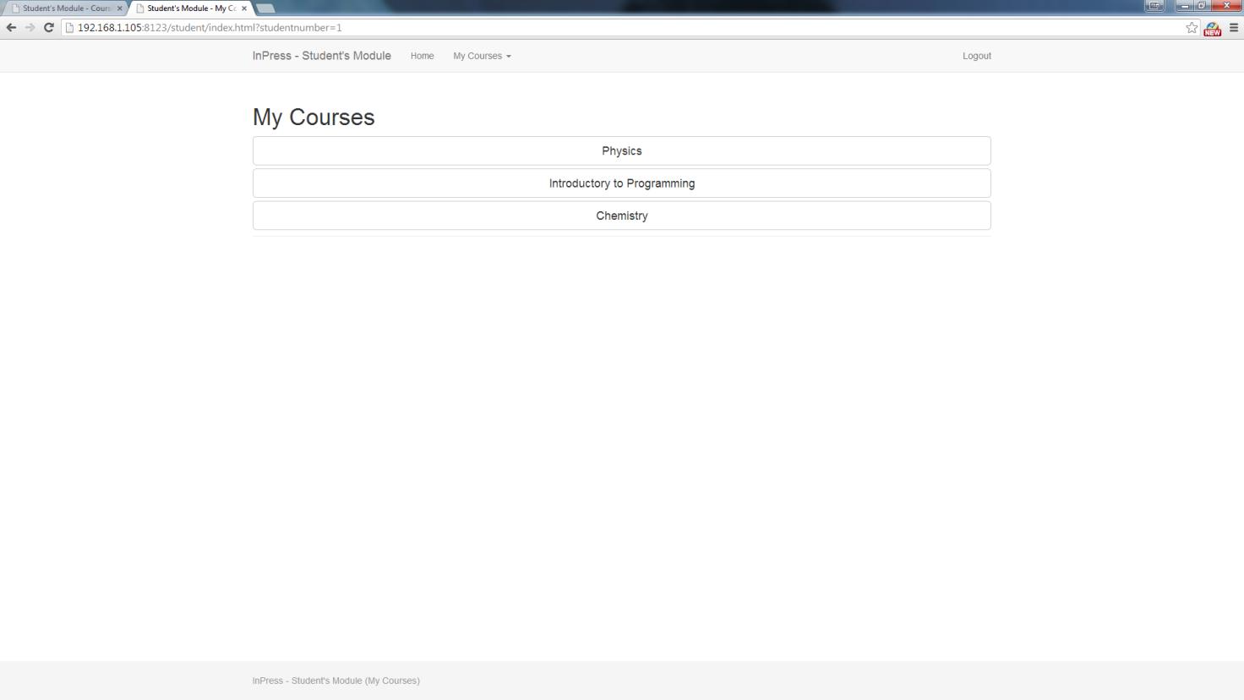

***Fig 4.0.2a – Course Selection Page***

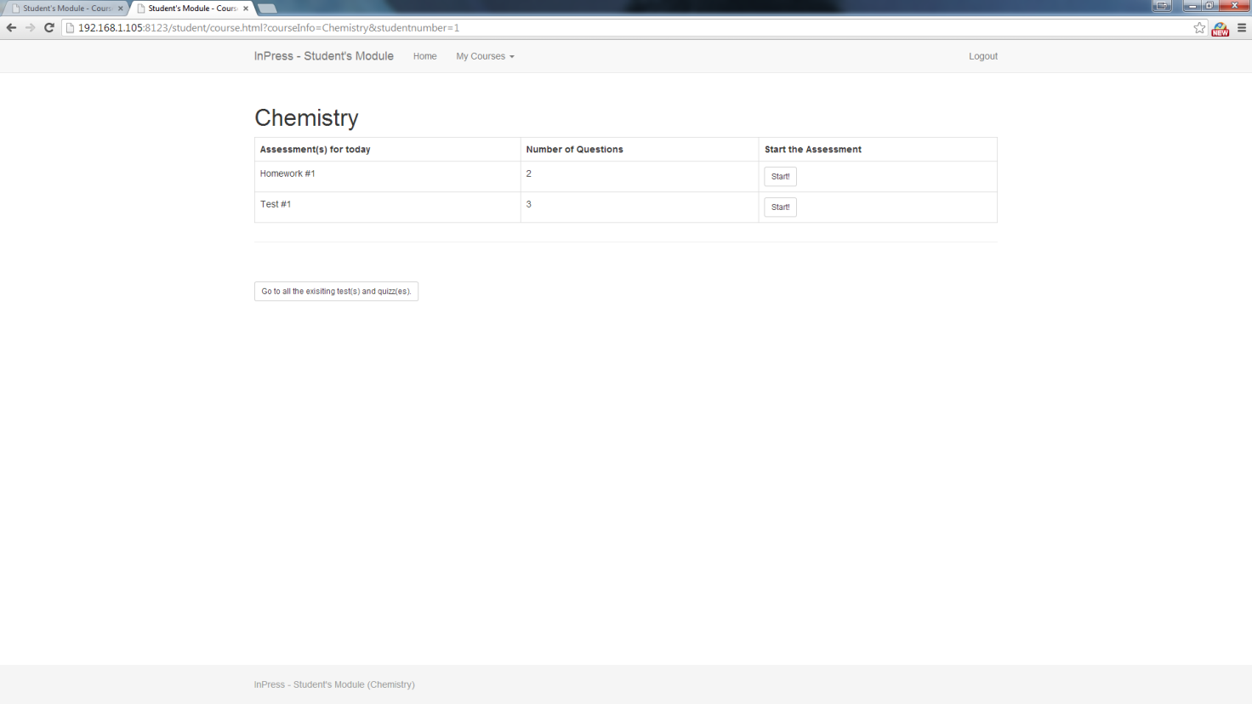

***Fig 4.0.2b – Assessments Page for Selected Course***

**4.0.3 Assessments**

1. Once you selected the course that you wish to work on (See **4.0.2** for Course Selecting), click on the button “Start!” on the Assessment you would like to work on. ***(Fig 4.0.2b)***
2. Answer the Questions, they could be in Multiple-Choice or Short Answer Styles. When you typed / selected your answer click on “Next Question” ***(Fig 4.0.3a)***
3. Upon the last Question, you will get to submit your Assessments. There will be a “Submit” button instead of the “Next Question” button in place ***(Fig 4.0.3b)***

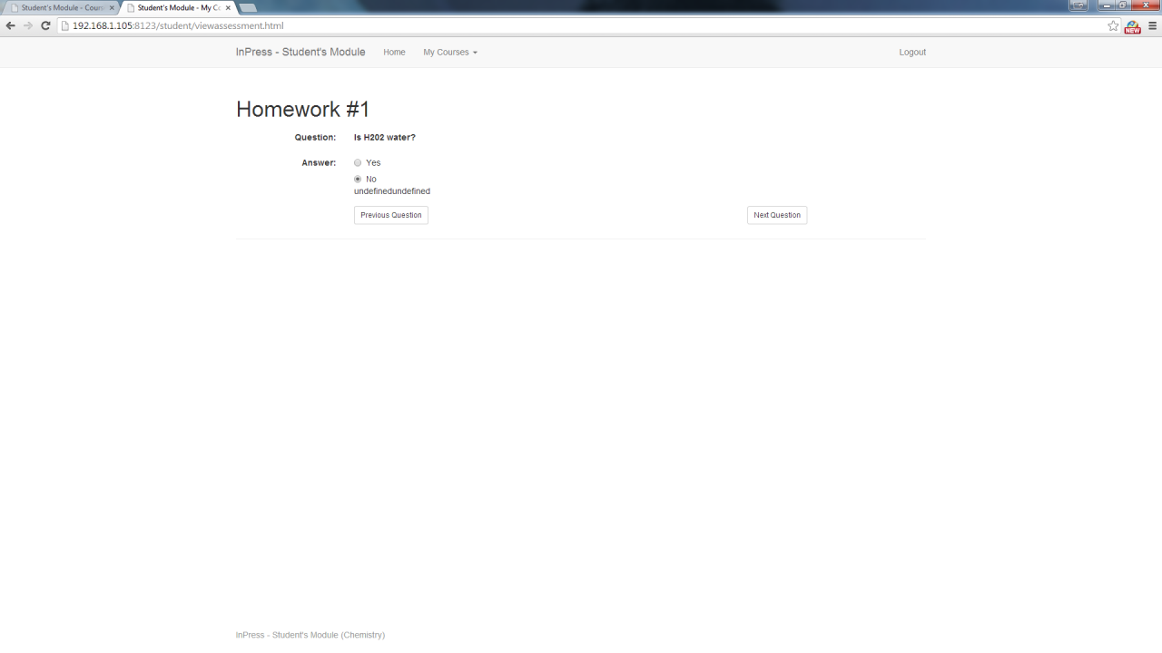

***Fig 4.0.3a – Answering Questions***

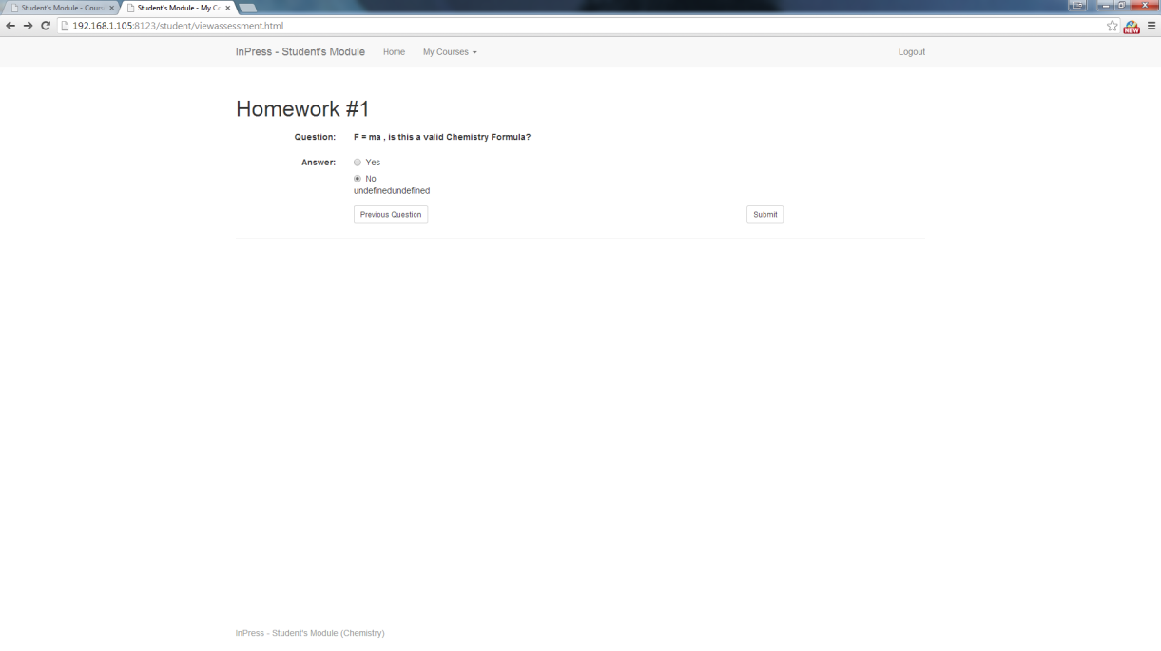

***Fig 4.0.3b – Submitting Assessments***

**4.0.4 Reviewing Assessments**

1. You can review your Assessments by click on the “Go to all existing test(s) and quiz(es)” button. ***(Fig 4.02b)***
2. You will be able to see all the Assessments that were completed with the solutions to the Assessments. Click on the Assessment to Expand to view full details. ***(fig 4.04a)***
3. To return to the course page you can click on “Home” or “Back to Course Page” button.

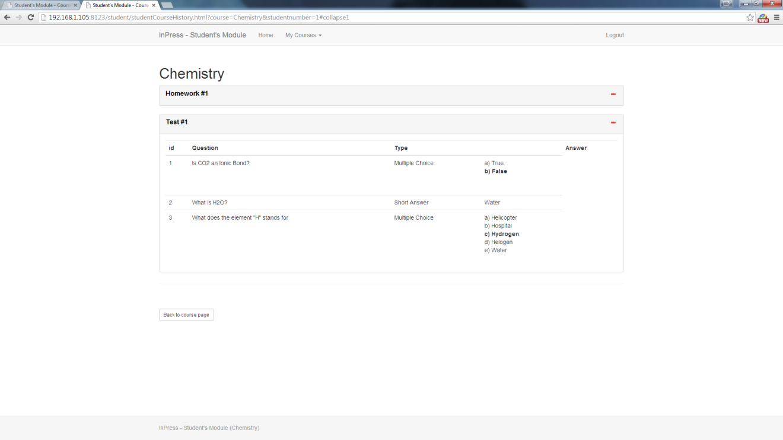

***Fig 4.04 – Reviewing***

# 5.0 Frequently Asked Questions

1. I need to change my password, how do it do this?

* Login to **<inpress address>/admin**.
* Top right corner “Change Password”

1. The instructor needs to change / lost his password

* Login to **<inpress address>/admin**.
* Instructors
* Click on Instructor ID
* Change the Instructor password at the Password Field
* Save